Agile Manifesto – argument for rapid iterative development. Lists what Agile process “Values”

Two main types of **Agile** – **Scrum** and **Kanban**. Kanban is basically just working off a list of ToDo items (backlog) The below items are regarding Scrum Agile.

Work Cycle: Usually 2-3 week **Sprints**. Teams picks what works best and sticks with it.

**Ceremonies** ([Scrum Sprint Cycle in 8 Steps (visual-paradigm.com)](https://www.visual-paradigm.com/scrum/scrum-sprint-cycle-in-8-steps/)):

1. Daily **Standup** (scrum) – Each person: “what did I do yesterday, what am I going to do today”
2. Weekly **Backlog Grooming/Refinement** – For stories in the Backlog:
   1. Fill out description.
   2. Fill out **Acceptance** **Criteria.**
   3. Create **Tasks**
   4. Estimate **Story Points**
3. **Sprint Planning** – Team decides what **Stories** to bring into the next **Sprint**.
4. **Sprint** **Demo** (last day of each sprint) – Show what has been accomplished in the **Sprint**.
5. **Sprint** **Retrospective** – Discuss “what went well” and “what could be improved” in the Sprint.

**Work Item** Hierarchy:

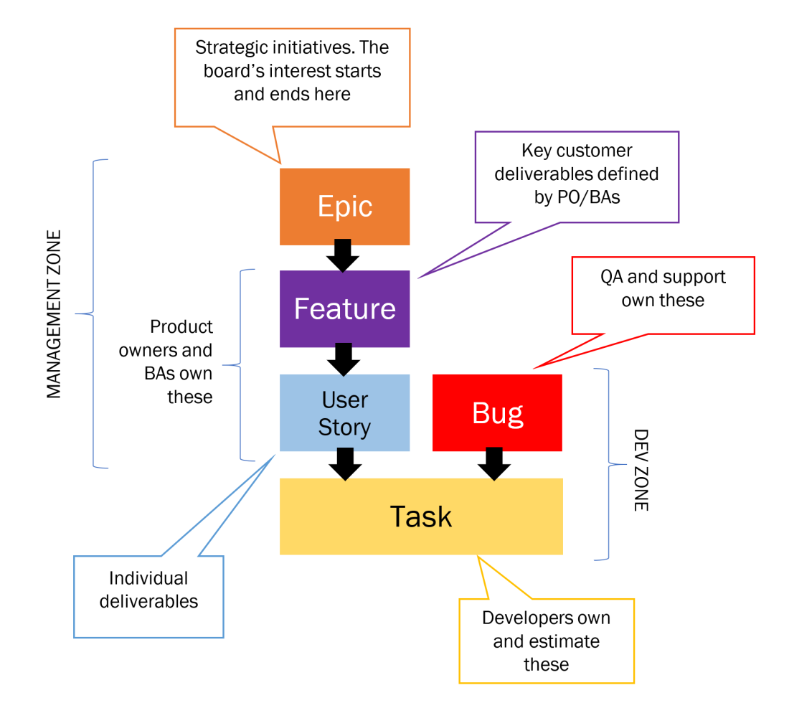

Actors:

1. **Product Owner** – Vision for the Product, defines needed functionality for the coming months/year, works with the Stakeholders (customers)
2. **Scrum Master** – Runs the ceremonies
3. **Developers** – Develop the functionality specified by the user stories
4. **QA** (sometimes) – Do the User Acceptance Testing (UAT). If no QA, then Devs do this.

Tools:

1. **Backlog** – contains stories that need to be worked, in priority order, that are not in the current sprint.

* **Stories/Bugs** on backlog get groomed (**Tasks**/details filled out) during **Backlog Grooming** to get them ready for work

1. **Scrum Board** – Contains the stories (with their tasks) that are currently in work.
   * Reviewed at daily **Standup**.
   * Populated during **Sprint Planning**
   * **Stories** are added from the **Backlog**
   * Updated by **developers** as they complete **Tasks** and **Stories**
   * Can be a tool like jira, Azure Dev Ops, or just use Sticky Notes
2. **Story** – A complete user-perceivable (typically) piece of functionality that can be delivered in one sprint.
   * Effort estimated in **Story Points** (they do NOT map to hours). Measure of relative complexity. Numbers typically from Fibonacci sequence: 1,2,3,5,8, etc.
   * Broken down into **Tasks.**
   * Have **Acceptance Criteria** that defines when the story is completed.
3. **Team Velocity** – The number of **story points** the scrum team can deliver in a sprint